**Update November 2023  
“Unlocking God’s purpose in you   
through meeting the needs of others”**

**Christmas is coming!!!** And the Hamper packing will soon begin   
if you are interested in helping out on Wednesday & Thursday   
mornings from 22nd November please email Nicky: [camberleybesomhampers@gmail.com](mailto:camberleybesomhampers@gmail.com).

The Summer has been very busy with Food & Household pack referrals, plus 18 gift cards for Deichmann school shoes & of course the in coming Harvest which we are incredibly grateful for. So a massive **THANK YOU** to all the Churches and Schools who support us. Read on for more details: *Karen Kendall – Project Lead*

**Referral Statistics:** The Summer months Jul-Sept saw a 65% increase in food referrals from last year. In those months we delivered **421 food parcels** (of 3+ days of food) to **156 Unique households** made up of **393 individuals** (that’s **3,195 days of food** and **9,585** **meals).**

**Our current clients range from**:   
A family of 9 (mum, dad & 7 Children), *to a single vulnerable gentleman, vegetarian, living in emergency accommodation still recovering from a stroke using a crutch & Using a shared kitchen.*A Ukraine family of 6 (mum, dad, 4 children ages 12 to 1yrs), *to a teenager living at home but reportedly under-nourished, sleeping in damp bedding with no bed covers, needing particular dietary items to support their recovery!*   
A Single mum with a 19yr old plus 2 other children one of which has Sickle Cell Disease, *to a single mum suffering with Fibromyalgia with a 12yr old child.*   
In all these cases we aim to tailor what is best to support them.

Additionally, we provided **117 “24hr Emergency bags”** to Citizens Advice & Churches, **18 Household packs inc. 10 microwaves.**   
Town Ward was top in terms of delivery numbers, closely followed by St. Michael’s, Citizens Advice continue to be our highest referrer.

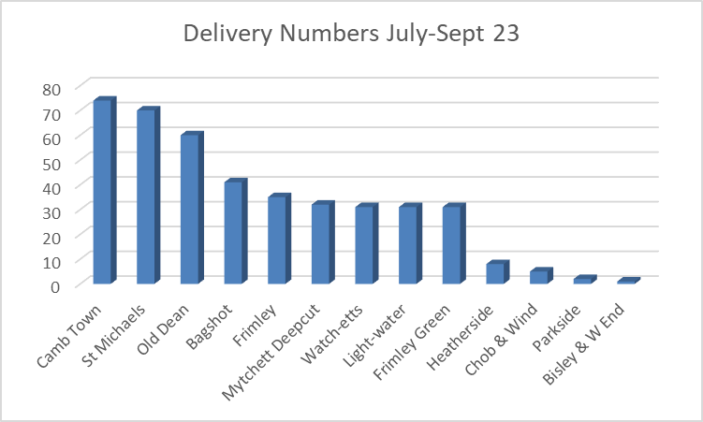

**Messages of thanks received:**

*Hi, lots of thanks for helping me I won’t forget the whole of my life your kindness Please pray for me……*

*Hello good afternoon, again you people make it hard for me to find enough words to say thank you for the microwave to make my life easier.*

**More thanks:** *I just want to thank you so much for your very generous items in the starter pack it really will be such a great help I can now concentrate on […..] without having to worry about pots/pans/plates and I can have a cup of tea!!! when I am more settled if you need some weekend volunteers, I would be happy to help I'm sure my 16-year-old daughter would as well [....] you have been so incredibly kind and have really given me a great start if I'm honest once you left, I had to take 5 minutes as I broke down in tears!  
-------------------------------*

*I have been getting some food parcels from you which has been a huge help. I don't know what I would do if it wasn't for the parcels. I am so incredibly grateful.*

**Time Givers update:** As I write there are 4 folk in the pipeline that have indicated they would like to give their time. If you know someone who is interested in joining us, we welcome people to visit the warehouse to see what we do and find out if there is anything God is calling them to give in either time or skills. **AGM:** On the 11th October we held our AGM. We shared our achievements and hopes for the future. The Trustees are quite a small team & meet just 6 times a year. At the AGM we invited offers from anyone who would consider becoming a Trustee, (as we are part of the Besom Network, a Christian organisation one stipulation is that all trustees are practicing Christians). Please do get in touch if you think you could you could offer your skills/experience to us as a Trustee.  
We also shared how over the past year we have reviewed & revised (where necessary) our Policy documents. Each policy that is relevant to Time-givers can be found in a folder in the Office & on our website, these include: **Safeguarding** / **Health & Safety** / **Bullying & Harassment** & **Whistleblowing**

**SPOTLIGHT: Nicky Lynch, Thursday Shift Lead & 2023 Christmas Hamper Coordinator**During Covid, I had begun volunteering behind the scenes helping run the Frimley admin side of Surrey Heath Prepared. A little while after Surrey Heath Prepared had finished, I was introduced to Besom.

When I was first welcomed into the amazing Thursday team, I began by helping in the office and making the client calls. I learnt a lot from Grace, who ran the shift at the time and everyone made me very welcome. When Grace retired, I became the Thursday Shift Lead.

I enjoy opening the warehouse, the stillness at the beginning of the shift, to the buzzing hive of activity it becomes as parcels are carefully packed, stock date checked, and donations unpacked, and shelves restocked. As a Shift Lead you maybe on a phone call one moment, ordering a restock of fresh fruit & vegetables the next, packing a ‘Kitchen Starter’ pack, printing off more packing slips or helping the rest of the team pack a parcel when its busy.

**Opportunity!   
Is God calling you to become a trustee or to take our minutes we meet 6 times a year!**

Please ask if you would like copies of these or would like to know any more about other policies.

now given out 18 of these to families referred to us over the summer.

**SPOTLIGHT Cont’d**: It can often be a busy shift, but we have fun and the team is brilliant to be a part of. I personally really enjoy reaching out to our clients, as we are careful to ask for any allergy or dietary information to aid us in packing their food parcels. It is most powerful to hear glimpses of the human stories behind the requests for help and for the client not to be just a number. Heartfelt gratitude is often expressed by many, but it is also sobering, when you realise the wide-ranging circumstances of those that are now seeking help.

I enjoy being part of the Besom team and helping others in times when they need it most. Giving to others has also, in turn, helped me, in a sense that I’ve regained confidence and sense of purpose following a life changing health issue a few years back. So, I personally know what a difference support from your local community can make, in whatever form that may take. I love being able to pay forward that kindness.

This year will be my first organising the Christmas Hampers operation, as Jane Bocutt has decided to step back from this role. Jane leaves big shoes to fill, having done an amazing job over the last few years! Packing of the Christmas Hampers is often a chance for others who may not be able to commit as a regular time giver, to come help for a few hours. Or it may be a first step to becoming a regular Time-Giver. We begin packing late November so do get in touch if you are interested.

**Harvest:** We have had a bumper Harvest again this year with donations from 13 Schools & 15 Church groups. It is a good challenge to have, trying to pack away the stock that will carry us through the winter months, thankfully this year we have already got the Trolley cages we bought for the overflow area last year.   
God is good! 

 **Schools Breakfast club:** We have delivered another car full of breakfast provisions to the School breakfast club, **we continue to welcome contributions**!

**Windlesham Golf Club an amazing fundraising success!**In the Summer of ‘22we wereapproached by Stuart Curtis from Windlesham Golf Club, he was about to become the Club’s Captain. He generously offered us the opportunity to be his sponsored charity for the year! Throughout the year they held a number of events including: **Master Sunday**: – Players donated to have a junior caddie in the traditional white boiler suits:

**Coronation Shotgun**: – Auctioned a magnificent cake made by one of their members, it is all edible!

**Summer Raffle:**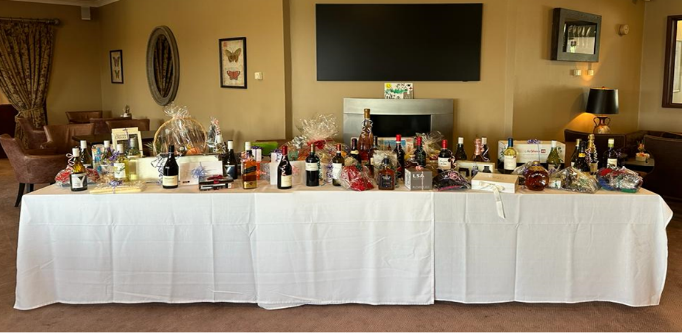…and we have just received the proceeds of all their hard work!

An incredible **£20,600!**

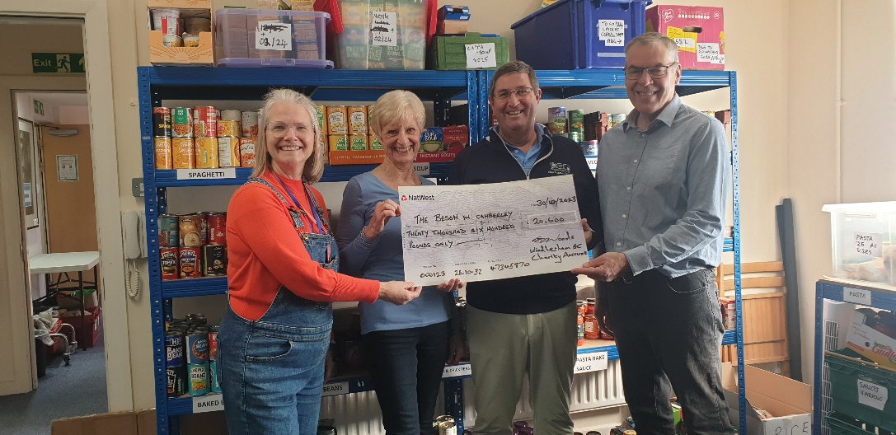

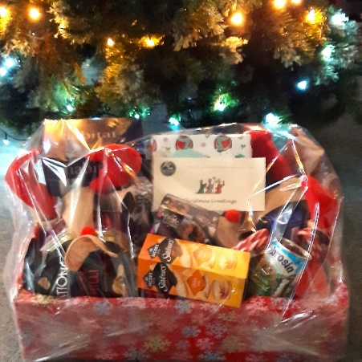**Christmas Hamper Donations:**    
I have attached our 2023 Christmas Hamper flyer with this Newsletter so if you are reading a printed copy please ask your Church rep or Administrator for a copy. Please consider packing a whole hamper or contributing any of the items on the Christmas list (deadline 1st Dec) which includes :

|  |  |
| --- | --- |
| Christmas Cake | Mince Pies |
| Chocolates | Crisps or Nibbles |
| Tin Salmon | Tin Ham |
| 400g tin fruit | Packet Custard |
| Angel Delight. | Stuffing Mix |
| Cranberry Sauce | Poultry gravy mix |
| Jar Pickle | Savoury Biscuits |
| Jar Coffee | Christmas Crackers |
| Packet Napkins | Christmas Biscuits |
| Chocolate Log or Christmas Pudding (pref. alcohol free) | New Wrapped Gift(s) (please specify age group & gender) |

**A Date for your diary:   
Waitrose Bagshot trolley collection**:   
If any of you would like to help us out for an hour or so at Waitrose in Bagshot on the **1st December** then please let us know we could do with some more help! We will be there between 9am – 3pm doing a general collection.

**Prayer Thanks & Needs:**

1. Thank God for his abundant generosity & for all those that give, be it in time, money, skills or “things”.
2. Pray especially for the Shift Leads who put in some considerable hours each week & Drivers who often do 2 or 3 runs to fit all the packs in their cars.
3. Pray for those referred to us, struggling financially & many who struggle with their mental health.
4. Pray for a balance of donated ambient food stock

**🙞 Thank you for reading this – please share it with your church/friends 🙜**

**Contact Email:** [camberleybesom@gmail.com](mailto:camberleybesom@gmail.com) **Mobile:** 07527 396683